➊ 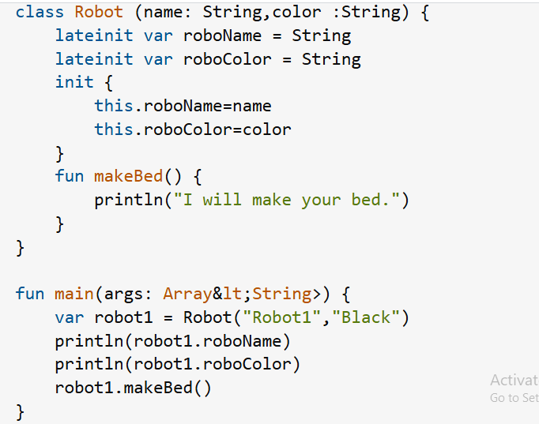

➋ 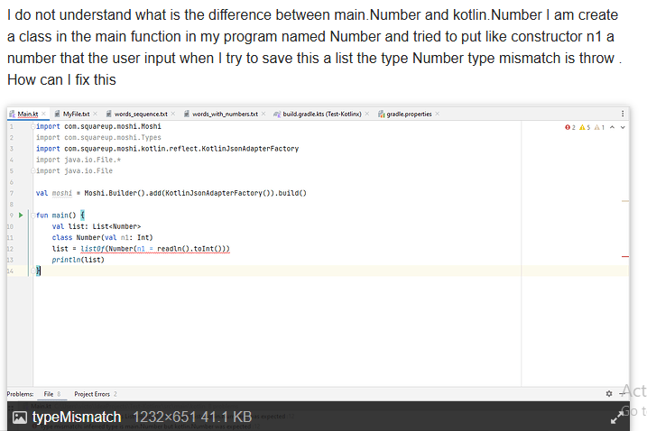

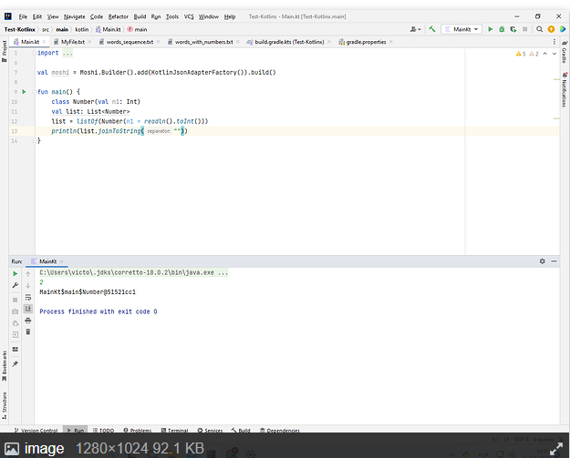

3. <https://stackoverflow.com/questions/73205321/preview-must-be-a-top-level-declarations-or-in-a-top-level-class-with-a-default>

4. <https://stackoverflow.com/questions/73205321/preview-must-be-a-top-level-declarations-or-in-a-top-level-class-with-a-default>

5. <http://reddit.com/r/android_devs/>